

Complaints Policy and Procedure

Regulation 16: Receiving and Acting on Complaints

Care Quality Commission (CQC) Fundamental Standards

Policy Title: Complaints Policy and Procedure

Regulation: Regulation 16: Receiving and Acting on Complaints Health and Social Care Act 2008 (regulated activities) regulations 2014

Outcome: This policy will outline the process for complaints to be raised by service users, and support staff to appropriately handle complaints that are raised.

Authorised By: Smaira Rana, Chief Assurance Officer

Issue Date: 22nd November 2023

Review Date: 22nd November 2025

Version Control

QF3 | Complaints Policy and Procedure
Version | Date | Author | Approved | Review Date
2.0 | 22/11/23 | Nicole Bransfield  Patient Experience and Safety Manager | Smaira Rana  Chief Assurance Officer | 22/11/25

Amendment Sheet
Amendment No. | Comments | Completed By | Date
Version 2.0 |  | Nicole Bransfield | November 2023

Contents

Contents

Complaints Policy and Procedure 1
Regulation 16: Receiving and Acting on Complaints 1
Amendment Sheet 2
Contents 3
Introduction 4
Scope 5
Objectives 5
Policy 5
Procedure 7
Accountabilities and Responsibilities 11
Training 12
Audit and Evaluation 12
Key Facts – Professionals 12
Key Facts – People affected by the service 13

Introduction

When service users have concerns about the service they have received, they have a right to raise a complaint with Psychiatry-UK for investigation. The purpose of this policy is to provide a clear method for service users to raise these concerns and receive a thorough response to their complaint.
This policy dovetails with other relevant policies and procedures and so must be referred to for further guidance and standards.
These include:
Disciplinary Policy
Incidents Policy
Performance Management Policy
Safeguarding Policy
Quality Assessment and Assurance Policy

To support Psychiatry UK in meeting the following Key Lines of Enquiry/Quality Statements (New):
Key Questions Key Lines of Enquiry Quality Statements
CARING | C2: How does the service support people to express their views and be actively involved in making decisions about their care, support, and treatment as far as possible? | QSC2: Treating people as individuals
RESPONSIVE | R2: How are people’s concerns and complaints listened and responded to and used to improve the quality of care? | QSR4: Listening to and involving people
SAFE | S1: How do systems, processes and practices keep people safe and safeguarded from abuse? | QSS3: Safeguarding

To meet the legal requirements of the regulated activities that Psychiatry UK is registered to provide:
- Compensations Act 2006
- The Care Act 2014
- The Health and Social Care Act 2008 (regulated activities) Regulations 2014
- Human Rights Act 1998
- National Health Service Complaints (England) Regulations 2009
- Mental Capacity Act 2005
- Mental Capacity Act Code of Practice
- Data Protection Act 2018
- UK GDPR

Scope

The following roles may be affected by this policy:

- All Staff

The following Patient, Parent, Individuals may be affected by this policy:
- Patient, Parent, Individuals

The following stakeholders may be affected by this policy:
- Family
- Advocates
- Representatives
- Commissioners
- External Health Professionals
- NHS
- External regulators

Objectives

To improve the quality of the patients and or individuals experience.
To ensure that all complaints and suggestions are promptly addressed, resolved, and shared within the agreed timescales to ensure that lessons are learned and that the learning improves service quality and delivery.

Policy

Psychiatry UK places a high priority upon the handling of complaints and recognises that suggestions, constructive criticisms, and complaints can be valuable aids to improving services.
The primary objective of this procedure is to provide the fullest opportunity for investigation and resolution of the complaint, aiming to satisfy the complainant that their concerns have been addressed, whilst being fair to staff and the complainant alike.
Complaints may be made by existing or former patients or anyone acting on the behalf of the patient with their consent. If the patient is unable to act, consent should be sought from the next of kin. This must be done before confidential, or information of a sensitive nature, is released to a third party.
Complaints can be a mechanism for identifying where improvements in service provision can be made. When used in this way, they are a positive tool for promoting organisational and individual learning thereby reducing risk to patients, staff, and the organisation. The complaints procedure is designed to develop a just and not a ‘blaming’ culture within the organisation.
Psychiatry UK will support and train staff to effectively support patients in raising concerns and investigate complaints.
Staff are responsible for:
- Complying with the standards in this policy
- Documenting the findings of complaint investigations and responding appropriately
- Appropriately utilising the internal feedback and learning outcomes identified during complaint investigations
- Attending training as per the training matrix at Psychiatry UK.

Patient Authorisation

Psychiatry UK will not undertake an investigation of any complaint verbal or informal until the appropriate patient/next of kin authorisation has been received. Patient authorisation is required whenever personal information, including medical records, is consulted as part of Psychiatry UK’s investigation.
Patient
The patient needs to confirm that Psychiatry UK can have access to personal information as part of the investigation process. If the patient is unable to give their consent, consent should be sought from the next of kin, especially when information from medical records will be required to answer the complaint.
Third party
Authorisation is almost always required before confidential information of a sensitive nature is released to a third party. This is particularly relevant where the complaint is made on behalf of a patient for example spouses, relatives, friends. However, in the case of MPs, there is ‘assumed consent’ and therefore confirmation of authorisation is not required, unless the MP is also representing a third party.
Children
The representative must be a parent, guardian, or other adult person who has care of the child; where the child is in the care of the local authority or voluntary organisation, the representative must be a person authorised by the local authority or voluntary organisation.
Deceased or incapable person
The representative must be a relative or other person who, in the opinion of the Patient Experience and Safety Manager, has a sufficient interest in their welfare and is a suitable person to act as a representative. If the Patient Experience and Safety Manager is of the opinion that a representative does not have a sufficient interest in the person’s welfare or is unsuitable to act as a representative, Psychiatry UK will notify the person in writing, stating the reasons.

Procedure
When a patient is referred to the Patient Experience Team, the Patient Experience Liaison (PEL) will work with the patient to resolve their concerns. During this time, if a patient would like to raise a complaint, the PEL will support them in doing so.

Raising the Complaint

For a complaint to be raised with Psychiatry-UK, either the Psychiatry-UK Complaint Form or Psychiatry-UK Written Complaint Form must be completed and then the form must be approved by the patient or their representative.

When a complaint is raised via a call with the patient, the PEL must complete the Psychiatry-UK Complaint Form within two working days, unless otherwise agreed with the patient. This form is then shared with the patient/representative to approve.

When a patient does not wish for a call to discuss their complaint, the PEL must share the Psychiatry-UK Written Complaint Form with the patient. If the patient has already submitted a written complaint in a different format and stated that they do not want a call, the complaint should be transferred to the Psychiatry-UK Written Complaint Form by the PEL within two working days, then shared with the patient/representative to approve.

Complaint Records

A record will be held of all complaints raised and include the following information:
- Each complaint received.
- Subject matter and outcome.
- The level, type, and category of each complaint.
- Details of any reason for delay where investigations took longer than the agreed response period.
- The date the report of outcome was sent to the complainant.

In addition to the Complaint Log, a complaint folder will be created for each complaint, which will contain the complaint form, any relevant communications regarding the complaint investigation, the complaint investigation form, and a copy of the complaint response sent to the patient.

Where a complaint indicates the potential abuse of a patient and or individual, safeguarding policies will be followed, and necessary notifications made to the regulatory body.

Where complaints are shared as part of learning, the complaint will be anonymised so there is no identifiable patient or individual information, in line with UK GDPR (General Data Protection Regulation) and data protection law.

Investigating the Complaint

Thorough investigation of the complaint will be undertaken by the PEL in line with the level and severity of the complaint. This will include but is not limited to:

- Review of the patient’s MedQare portal record.
- Discussion with colleagues including the patient’s clinicians, non-clinical staff that had contact with the patient, relevant managers, and/or service leads.
- Further discussion with the patient if required.
- Examination of Psychiatry-UK processes, procedures, and policies that are pertinent to the concerns raised.

The investigation will be documented using the Complaint Investigation Form.

Responding to the Complaint

Following the investigation, the complaint will be responded to accordingly in line with the severity of the complaint and the level of investigation required, within 15 working days (Monday to Friday, excluding statutory holidays) of the complaint being raised.

This response by the PEL will outline the findings of the investigation and any learning outcomes taken forward.

Learning outcomes will also be discussed with the relevant team and recorded on the Complaint Log following the investigation and response.

Feedback on the Complaint Process

We gather feedback from every patient that makes a complaint. This request for feedback is sent one week after the final communication with the patient regarding the complaint unless it is appropriate to send it sooner.

The Complaint Log entry should be closed at this stage, though any further communication from the patient regarding their complaint should cause it to be updated accordingly.

When Complaints Cannot be Resolved Locally

If complaints cannot be resolved by the above process, then the patient and/or their representative should be advised that they have the right to escalate their complaint to the appropriate external body.

In respect of our NHS service the patient or their representative may contact the:

Parliamentary and Health Service Ombudsman
Millbank Tower,
Millbank,
London, SW1P 4QP
www.ombudsman.org.uk/making-complaint

In respect of our private service the patient or their representative may contact the:

Chartered Trading Standards Institute UK
www.tradingstandards.uk/consumer-help/

The Care Quality Commission

The Care Quality Commission will not investigate complaints on behalf of patients and or individuals but does like to be informed of any concerns regarding a care provider, such as poor care that has been seen or experienced. Information given to the CQC will help to prevent others from going through the same experience can be fed back via:

Website www.cqc.org.uk
Email enquiries@cqc.org.uk
Address Care Quality Commission (CQC)
National Correspondence
Citygate, Gallowgate
Newcastle upon Tyne, NE1 4PA
Tel: 03000 616161

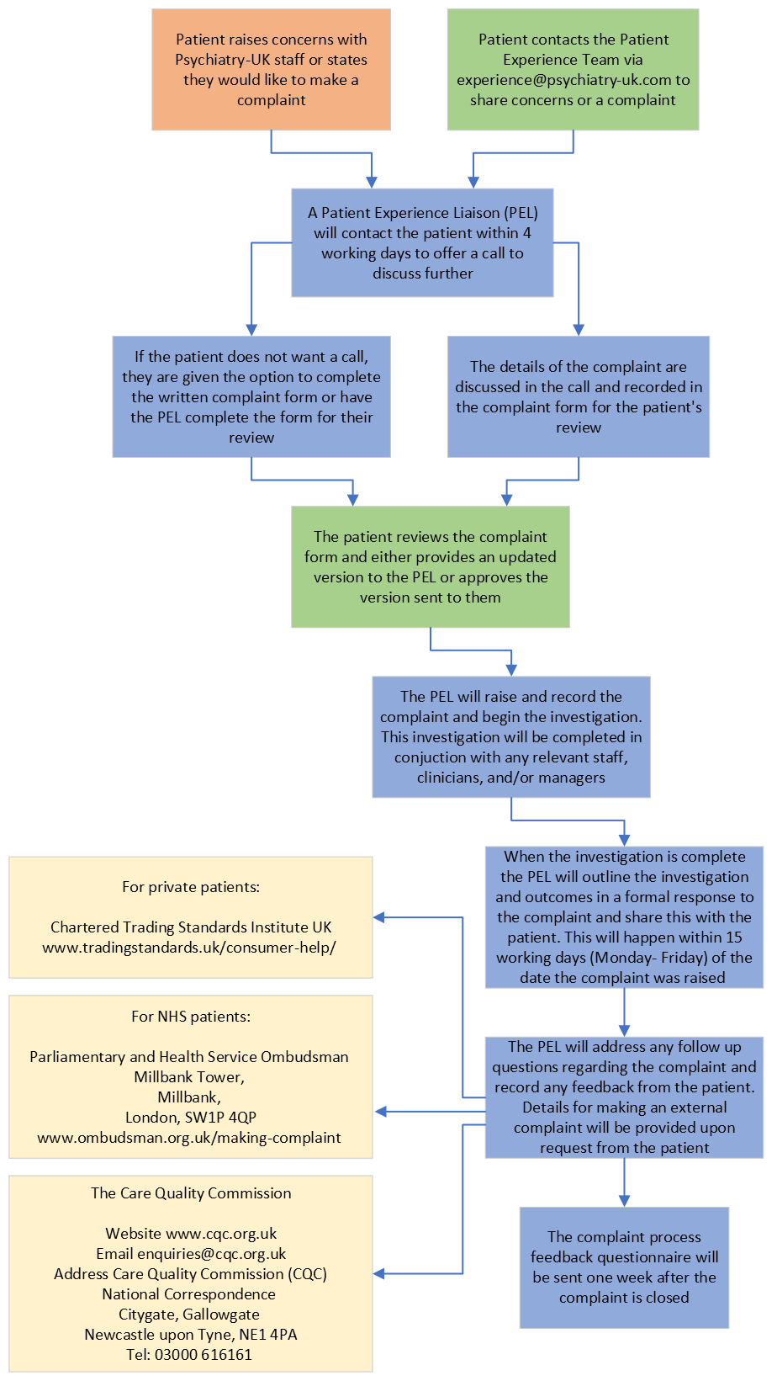
Psychiatry UK Complaint Process

Accountabilities and Responsibilities

The Chief Executive Officer will:
- Have the responsibility for scrutinising governance systems and processes at Psychiatry UK through quality assurance and internal audit.
- Ensure continuous improvement.
- Have an organisational structure in place that defines leadership and accountability.
- Ensure with Psychiatry UK that there is accessible engagement with patients, individuals, and staff to ensure that their views and feedback shape the service.

The Registered Manager will:
- Be responsible for the overall management of Psychiatry UK Limited.
- Delegate the responsibility and hold staff to account for agreed actions.
- Have governance systems that are effective, fit for purpose and achieve continuous improvement.
- Report statutory notifications and escalate concerns to the Board.

The Patient Experience and Safety Manager will:

- Be responsible for ensuring that the timeframes outlined in this policy are adhered to.
- Report on complaints and outcomes regularly within the Clinical Quality and Governance department and to other management structures within Psychiatry UK.
- Ensure that learning outcomes identified in complaint investigations are raised with the relevant team/department.
- Utilise patient feedback about the complaints procedure to ensure that this remains up to date and appropriately supports patients with raising concerns.

The Patient Experience Team will:

- Communicate in a timely manner with patients and their representatives regarding concerns and complaints.
- Be responsible for conducting the investigation of the complaint.
- Thoroughly document the complaint investigation and outcomes.
- Report the findings of the investigation to the relevant business areas and to the patient and/or their representative.

Training

Psychiatry UK will ensure all staff are aware of the process for patients to raise a complaint with the Patient Experience Team.
All Patient Experience Team staff must understand their responsibilities within the complaint procedure, including:
- Investigating the complaint and documenting these findings.
- Identifying areas of improvement and sharing learning outcomes internally.
- Reporting the findings and outcomes of the investigation to the patient and/or their representative.

Audit and Evaluation

All complaints will be managed by the Patient Experience Team, who will liaise with the relevant teams to reflect on practice and identify any learning which can be introduced as a means of quality assurance. Ideally, this will be disseminated throughout the organisation and recorded within Psychiatry UK’s weekly updates.
Relevant Team Leads and Line Managers will address any performance concerns with their staff when identified throughout the investigation process, in line with the Performance Management and Disciplinary policies. Managers and Leads will be responsible for implementing changes based on the investigation outcomes.
The complaint procedure and records of complaints will be regularly audited by the Internal Audit team within the Clinical Quality and Governance department audit schedule, for further information please refer to the Quality Assessment and Assurance Policy.

Key Facts – Professionals

All staff should be aware of the following:
- Patient concerns are to be escalated as soon as possible to the Patient Experience Team, to ensure that they can be addressed swiftly.
- Investigation of complaints follows a systems-based approach, with emphasis on areas of improvement within existing systems to prevent future issues.
- Every effort is made to resolve complaints locally, when possible, to the satisfaction of the patient.
- When a complaint identifies that something has gone wrong or has fallen below standards it is seen as an opportunity to improve and avoid a recurrence and it can allow for systems, policies, practices, or procedures to be amended or put in place as appropriate. If required, an incident should be raised to report any issues that need further investigation. Further information regarding incident reporting can be found in the Incidents Policy.

Key Facts – People affected by the service

People affected by this service should be aware of the following:
- Existing or former users of services provided by Psychiatry UK may complain. Other people may complain on behalf of existing or former users where Psychiatry UK accepts them as a suitable representative and where consent has been obtained.
- A complaint should be made as soon as possible after the event complained of. Normally a complaint should be made within six months of the event complained of, or within six months of the complainant first becoming aware of the problem. Psychiatry UK has the discretion to investigate complaints after this time if there is a good reason why the complaint could not be made sooner.
- Once a complaint has been made, the complainant has the right to have their concerns investigated; complaints will not affect current or future provision of treatment.
- All complaints will be kept confidential to the parties concerned unless a concern is raised in relation to a safeguarding matter or in relation to serious criminality in which case, we reserve the right to escalate the matter to relevant authorities. The complaint will be made known to the relevant management teams within Psychiatry UK and will be discussed with the Board of Designated Members where necessary.
- We have the right to refuse to accept a complaint where the complaint is clearly vexatious, malicious, or motivated by racist, sexist, homophobic or other discriminatory attitudes, or where the complaint threatens or abuses Psychiatry UK staff. The decision as to whether a complaint is vexatious will be taken by the Patient Experience and Safety Manager. Psychiatry UK defines a vexatious complainant as someone who persists in making a complaint or demand when all reasonable attempts to resolve their concerns have been made.

